**I INTRODUCTION**

**1.1 An Overview :**

The **College Event Registration System** is a web-based application developed to simplify and automate the management of college events and student registrations. In many educational institutions, event registration and coordination are handled manually using paper forms or unorganized digital methods, which often result in data redundancy, errors, and delays. This system provides a centralized and efficient digital platform for managing events in a structured and secure manner.

The system is designed with **role-based access control** to ensure proper authorization and data security. The **Admin** acts as the super-user of the system and is responsible for uploading student details in bulk, creating organizer accounts, and monitoring the overall system activities. The admin dashboard provides real-time insights such as the total number of students, organizers, events, and registrations, enabling effective system management.

The **Organizer module** is managed by department staff members who are authorized to create and manage events related to their respective departments. Organizers can add event details such as event name, date, venue, rules, and registration limits. They can also view registered students for their events and track participation efficiently. Each organizer has access only to events created by their department, ensuring data integrity and controlled access.

The **Student module** provides a user-friendly dashboard where students can view and register for events. Events are clearly categorized into **Free Events** and **Paid Events**, allowing students to easily choose according to their preference. Students can register online using their login credentials, select games or activities, and upload payment references for paid events when required. The student dashboard also allows students to view their registered events and notifications related to upcoming activities.

The system is developed using **HTML, CSS, and JavaScript** for the front end, **PHP** for server-side processing, and **MySQL** for database management. It features a modern, responsive design compatible with multiple devices, ensuring smooth navigation and ease of use.

**1.2 Objectives of the Project**

The primary objective of the **College Event Registration System** is to develop a centralized, efficient, and user-friendly web-based platform that automates the process of managing college events and student registrations. The system is designed to replace traditional manual methods with a secure digital solution that improves accuracy, transparency, and administrative efficiency.

One of the key objectives of this project is to simplify event management for college authorities and department organizers. The system provides a dedicated **Organizer module** for department staff members, enabling them to create, update, and manage events easily. Organizers can define event details such as event name, date, venue, rules, and registration limits, and can view registered students for their events. This reduces paperwork, minimizes human errors, and ensures organized event handling.

Another important objective is to streamline the **student registration process**. Students can log in through their personalized dashboard and view events categorized into **Free Events** and **Paid Events**. This clear separation helps students choose events conveniently. Students can register online using their roll number credentials, select events or games, and upload payment references for paid events, eliminating the need for physical registration forms and long queues.

The project also aims to ensure **role-based access control and data security**. Different user roles such as **Admin, Organizer, and Student** are provided with specific permissions. The admin has complete control over the system, including uploading student data and managing organizer accounts. Organizers can access only their department events, while students can view and manage only their own registrations. This structure ensures data integrity and prevents unauthorized access.

Another objective is to provide **real-time monitoring and reporting** facilities. The admin dashboard displays automatic counts of students, events, organizers, and registrations. These real-time insights help administrators track participation levels, analyze event performance, and support better planning and decision-making for future events.

Finally, the system aims to **reduce manual workload and operational costs** by automating repetitive tasks such as student account creation, registration tracking, and record management.

**1.3 Organization of the Project**

**1.4 Scope Of The System**

The **College Event Registration System** is designed to provide a comprehensive, structured, and automated solution for managing college-level events and student participation through a centralized web-based platform. The scope of this system defines the boundaries, features, and operational capabilities covered by the project. It focuses on digitizing event management, student registration, monitoring, and administrative control while ensuring security, accuracy, and ease of use.

The system is intended for use within an educational institution and supports multiple user roles, including **Admin, Organizer (Department Staff), and Student**, each with clearly defined responsibilities and access privileges.

### **Administrative Scope**

The Admin module forms the core of the College Event Registration System and provides complete control over the application. The admin acts as the super-user and is responsible for managing the overall system configuration and data integrity.

Within this scope, the admin can create and manage organizer accounts, where organizers are designated **department staff members**. The admin can also **upload student details in bulk**, assign departments, and manage student login credentials, eliminating the need for manual student registration.

The admin has the authority to view all events (both free and paid), monitor total registrations, and generate consolidated reports. The admin dashboard displays real-time statistics such as total number of students, organizers, events, and registrations. This scope ensures centralized supervision, efficient data management, and effective decision-making through a single control panel.

### **Organizer Scope**

The Organizer module is designed for **department staff members** who act as event coordinators. This scope allows organizers to independently manage events related to their respective departments without interfering with other departments’ data.

Organizers can create new events and specify detailed information such as event name, date, venue, rules, and participant limits. They can also classify events as **Free Events or Paid Events**, allowing better clarity for students during registration. For paid events, organizers can define registration fees and view payment reference details submitted by students.

Each organizer can view and manage only the events created by them, ensuring data privacy and accountability. Organizers can track real-time registration counts, helping them plan logistics such as seating arrangements, materials, and scheduling. This scope reduces dependency on the admin for daily event operations and supports decentralized event management.

### **Student Scope**

The Student module provides a user-friendly and interactive interface that enables students to participate actively in college events. Students can log in using credentials provided by the admin and access a personalized **Student Dashboard**.

From the dashboard, students can view events categorized into **Free Events and Paid Events**, making it easier to identify suitable events. Students can register online, view event details such as date and venue, and upload payment references for paid events where required. They can also view their registration history and event status, ensuring transparency and confirmation of participation.

This scope eliminates the need for physical registration forms, manual data entry, and long queues, thereby saving time and reducing errors for both students and staff.

**II SYSTEM ANALYSIS**

## ****2.1 Existing System****

In the existing system, event management and student registration activities are mostly handled using **manual or semi-computerized methods**. Colleges and institutions depend on paperwork, registers, Excel sheets, and basic communication methods such as notice boards or verbal instructions. Event details, student participation, and payment information are recorded separately, which leads to duplication of work and data inconsistency.

Student details are maintained manually, and registration for events is often done by filling paper forms or submitting details through informal channels. This process is time-consuming and requires significant human effort. Event organizers must manually verify student eligibility, count registrations, and maintain attendance records. Payment confirmation is also handled manually, making it difficult to track transaction status accurately.

There is no centralized system to manage **admin, organizer, and student roles** separately. Access control is weak, and data security is minimal. Retrieving information such as event-wise registrations, payment details, or student participation history is difficult and slow. Reports must be prepared manually, increasing the chances of errors.

Additionally, the existing system does not support real-time updates. Any change in event details or registration status must be communicated manually, which can lead to confusion and misinformation. Data storage in physical files is not secure and may be lost or damaged over time.

Overall, the existing system lacks **automation, accuracy, security, scalability, and efficiency**, making it unsuitable for managing large numbers of students and events in modern educational institutions.

## ****Proposed System****

The proposed system is a **web-based College Event Registration System** designed to overcome the limitations of the existing manual and semi-automated methods used for managing college events. It provides a **centralized, automated, and secure platform** for handling event creation, student participation, and administrative control in an efficient and organized manner.

The system automates the complete lifecycle of college event management, from event creation to student registration and reporting. All data related to students, department staff (organizers), events, registrations, and payments are stored in a **centralized database**, ensuring accuracy, consistency, and easy retrieval of information.

Key features of the proposed system include:

* The system is a **web-based application** that automates the entire college event management and student registration process.
* It uses a **centralized database** to securely store student details, organizer (department staff) information, event data, registration records, and payment references.
* The system supports **role-based access control** for Admin, Organizer, and Student, ensuring secure and controlled usage.
* The **Admin module** allows the admin to upload student details in bulk, create and manage organizer accounts, monitor events, and view overall system statistics through a dashboard.
* The **Organizer module**, used by department staff, enables organizers to create and manage events, classify events as **free or paid**, view registered students, track payment references, and download event-wise reports.
* The **Student module** provides a dedicated **student dashboard** where students can view available events categorized into **free events and paid events**, register online, and upload payment references for paid events.
* The system significantly **reduces manual work and paperwork**, minimizing errors and saving time for students, organizers, and administrators.
* **Real-time updates** ensure that registrations and payments are immediately reflected in the system.

**2.3 Hardware Specification :**

* **Processor :** Intel i3
* **RAM :** 4 GB
* **Operating System :** Windows 10

**2.4 Software Specification :**

* **Front End :** HTML ,CSS And Java Script
* **Back End :** PHP
* **DataBase :** MYSQL

## ****1. HTML (HyperText Markup Language)****

HTML is the basic language used to create the structure of web pages. It defines the content that appears on the screen such as headings, paragraphs, forms, tables, images, and links. In this project, HTML is used to design pages like login forms, dashboards, student lists, event details, and reports. HTML works as the skeleton of the website. Without HTML, the web page cannot display any content. It is easy to learn and is supported by all web browsers.

## ****2. CSS (Cascading Style Sheets)****

CSS is used to style and design the HTML content. It controls the layout, colors, fonts, spacing, borders, buttons, and overall look of the website. In this project, CSS is used to create a modern and attractive user interface for admin, organizer, and student dashboards. It also helps in making the website responsive so it works well on different screen sizes. CSS improves user experience by making the system visually appealing and easy to use.

## ****3. JavaScript****

JavaScript is a client-side scripting language used to make web pages interactive. It is mainly used for form validation, dynamic content loading, button actions, alerts, and confirmations. In this project, JavaScript is used to validate input fields, show or hide forms, confirm delete actions, and improve page interaction without reloading. JavaScript runs in the browser, making the system faster and more responsive. It enhances user interaction and reduces server load.

## ****4. PHP (Hypertext Preprocessor)****

PHP is a server-side scripting language used to handle the backend logic of the system. It processes user requests, manages sessions, connects to the database, and executes business logic. In this project, PHP is used for login authentication, student creation, event management, registrations, data filtering, and report generation. PHP securely processes form data and communicates with the MySQL database. It is widely used for web applications because it is simple, powerful, and integrates well with databases.

## ****5. MySQL (Database)****

MySQL is a relational database management system used to store and manage application data. It stores information such as student details, event data, registration records, user accounts, and payment details. MySQL uses tables, rows, and columns to organize data efficiently. In this project, MySQL allows fast data retrieval and secure storage. It supports SQL queries for inserting, updating, deleting, and selecting data. MySQL ensures data accuracy, consistency, and reliability.

**III DESIGN AND DEVELOPMENT**

**3.1 Design Process :**

**DFD Diagram :**

The below diagram represents the **Data Flow Diagram (DFD)** of a **College Event Registration System**, which shows how data moves between users, processes, and databases. The system mainly involves **three external entities**: **Admin**, **Organizer**, and **Student**.

### **1. External Entities**

#### **Admin**

* The Admin is responsible for **managing users**, **system settings**, and **generating reports**.
* Admin interacts with the **Admin Panel** to control the overall system.
* Admin ensures smooth functioning and security of the system.

#### **Organizer**

* The Organizer creates and manages events.
* Organizers view event-related reports such as registration details.
* They interact with the system to publish event information for students.

#### **Student**

* Students view available events and register for them.
* They provide personal and registration details.
* Students may also perform payment-related actions if applicable.

### **2. Processes**

#### **1.0 Admin Panel**

* This is the central control unit of the system.
* It handles admin activities such as:
  + User management
  + System configuration
  + Report generation
* It sends system data and event-related information to other processes.

#### **2.0 Event Management**

* This process manages all event-related operations.
* It receives event creation details from organizers.
* Event information is stored and retrieved from the **Central Database (D1)**.
* It forwards event details to the Student Registration process.

#### **3.0 Student Registration**

* This process manages student registrations for events.
* Student registration data is collected and processed.
* Payment and registration information is stored in **Payment Records (D2)**.
* Registration confirmation is provided to students.

### **3. Data Stores**

#### **Central Database**

* Stores student details, event information, and system data.
* 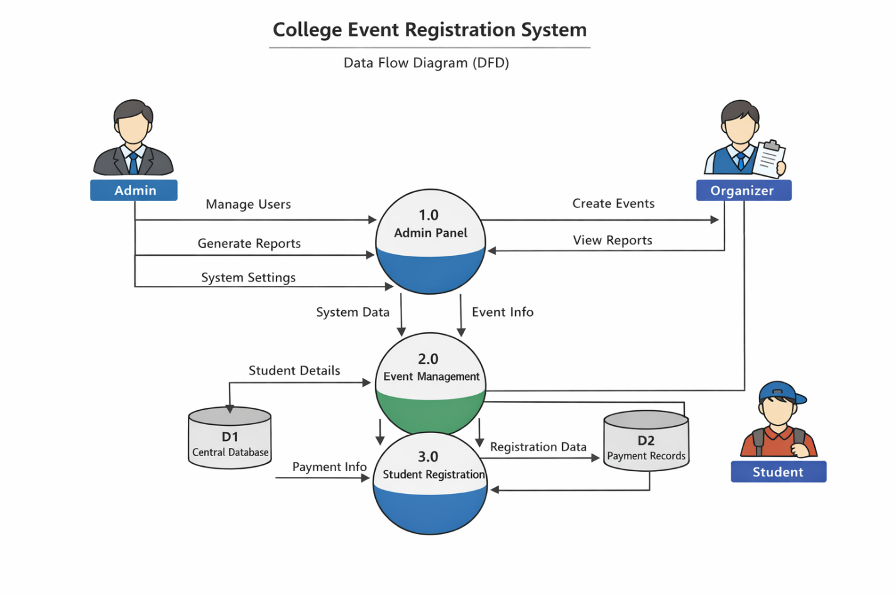Used by Event Management and Admin Panel for data retrieval and store

**3.1.1 DataBase Design**

**Admin Table :**

|  |  |
| --- | --- |
| **Field** | **Type** |
| **Id** | **int(11)** |
| **Username** | **varchar(50)** |
| **Password** | **varchar(50)** |

**Student Table :**

|  |  |
| --- | --- |
| **Field** | **Type** |
| **id** | **Int(11)** |
| **Serial_no** | **Int(11)** |
| **Name** | **Varchar(100)** |
| **Roll_no** | **Varchar(20)** |
| **Degree** | **Varchar(20)** |
| **Branch** | **Varchar(20)** |
| **Year** | **Int(11)** |
| **Username** | **Varchar(50)** |
| **password** | **Varchar(100)** |

**Events Table :**

|  |  |
| --- | --- |
| **Field** | **Type** |
| **Id** | **Int(11)** |
| **Organizer_id** | **Int(11)** |
| **Event_name** | **Varchar(100)** |
| **Event_date** | **Date** |
| **Event_time** | **Time** |
| **Venue** | **Varchar(100)** |
| **Fee** | **Decimal(10,2)** |
| **Payment_details** | **Varchar(200)** |
| **Department** | **Varchar(100)** |
| **Rules_file** | **Varchar(255)** |
| **status** | **Enum(‘open’,’closed’)** |

**Games Table :**

|  |  |
| --- | --- |
| **Field** | **Type** |
| **Id** | **Int(11)** |
| **Event_id** | **Int(11)** |
| **Game_name** | **Varchar(100)** |

**Notifications Table :**

|  |  |
| --- | --- |
| **Field** | **Type** |
| **Id** | **Int(11)** |
| **Event_name** | **Varchar(50)** |
| **Message** | **Varchar(255)** |
| **Notify_date** | **date** |
| **Created_at** | **Datetime** |
| **Event_id** | **Varchar(12)** |

**Organizer Table :**

|  |  |
| --- | --- |
| **Field** | **Type** |
| **id** | **Int(11)** |
| **Username** | **Varchar(50)** |
| **password** | **Varchar(100)** |
| **department** | **Varchar(20)** |

**Registrations Table :**

|  |  |
| --- | --- |
| **Field** | **Type** |
| **Id** | **Int(11)** |
| **Student_id** | **Int(11)** |
| **Event_id** | **Int(11)** |
| **Games_selected** | **Varchar(200)** |
| **Payment_ref** | **Varchar(100)** |
| **Phone** | **Varchar(20)** |
| **Email** | **Varchar(100)** |

**3.1.2 Input Design**

Input Design is an important phase in the development of the **College Event Registration System**. It focuses on how data is entered into the system and ensures that the input provided by users is accurate, complete, and secure. Proper input design reduces errors, improves system efficiency, and enhances user satisfaction.

In this system, input is collected from three main users: **Admin**, **Organizer**, and **Student**. Each user has specific input forms designed according to their roles.

### **1. Admin Input Design**

The Admin provides input through secure forms in the Admin Panel. The main inputs include:

* Admin login credentials (username and password)
* Organizer creation details (name, email, phone, username, password)
* Student creation details (degree, department, year, number of students)
* Event approval and system configuration data

All admin input fields use validation such as mandatory fields, correct email format, and numeric checks to prevent invalid data entry.

### **2. Organizer Input Design**

The Organizer inputs data related to event management. The key input forms include:

* Organizer login details
* Event creation form (event name, date, time, venue, description, registration limit)
* Event status updates (active, closed, completed)

Input controls such as dropdown lists, date pickers, and text fields are used to ensure accuracy and consistency.

### **3. Student Input Design**

Students interact with the system mainly for event registration. Student inputs include:

* Student login credentials (username and password)
* Event selection
* Registration confirmation details

The student input forms are designed to be simple and user-friendly. Most data is auto-filled from the database to reduce manual errors.

### **4. Input Validation and Security**

The system implements various input validation techniques such as:

* Required field validation
* Length and format checks
* Duplicate entry prevention
* Server-side validation using PHP
* Protection against SQL Injection using secure queries

Passwords are securely handled, and unauthorized access is restricted through session management.

## 3.1.3 Output Design

Output Design refers to the way information is presented to the users after processing the input data. In the **College Event Registration System**, output design plays a crucial role in delivering accurate, timely, and meaningful information to different users such as **Admin**, **Organizer**, and **Student**. The system outputs are designed to be user-friendly, visually clear, and easy to interpret.

The main objective of output design is to ensure that the right information is provided to the right user in an appropriate format.

### **Admin Output Design**

The Admin receives comprehensive outputs to monitor and control the entire system. The admin dashboard displays:

* Total number of events
* Total number of organizers
* Total number of students
* Total registrations
* Event status reports

Tabular outputs are used to display organizer lists, student lists, and event details. Confirmation messages such as “Organizer Created Successfully” or “Student Deleted Successfully” are shown to inform the admin about performed actions.

### **Organizer Output Design**

Organizers receive outputs related to event management and registrations. The organizer dashboard displays:

* Events created by the organizer
* Number of students registered for each event
* Event status (Active, Closed, Completed)

Reports are displayed in table format for clarity. Success and error messages are shown after creating, editing, or deleting events. This helps organizers track event performance effectively.

### **Student Output Design**

Students receive simple and clear outputs to support easy interaction with the system. The student interface displays:

* List of available events
* Event details such as date, venue, and description
* Registration confirmation messages
* Registration status

Students are informed through messages like “Successfully Registered for Event” or “Registration Closed”.

### **Report Generation Output**

The system generates reports in tabular format that can be viewed on screen. These reports include:

* Event-wise registration reports
* Organizer-wise event reports
* Student participation details

These outputs help in analysis and decision-making.

**IV TESTING AND IMPLEMENTATION**

**4.1 System Testing :**

System Testing is a critical phase in the software development life cycle. It involves testing the complete and integrated system to verify that it meets the specified requirements and functions correctly under different conditions. In the **College Event Registration System**, system testing ensures that all modules such as **Admin**, **Organizer**, and **Student** work together properly and deliver accurate results.

The primary objective of system testing is to identify defects, validate system behavior, and ensure reliability, performance, and security before deployment.

## Purpose of System Testing

The main purposes of system testing in this project are:

* To verify that the system satisfies all functional requirements
* To ensure smooth interaction between modules
* To check data accuracy and consistency
* To identify and eliminate errors before implementation
* To confirm that the system is user-friendly and secure

## Types of System Testing Used

Several testing techniques were applied to ensure the quality of the system.

### **1. Functional Testing**

Functional testing verifies that each function of the system operates according to the specified requirements.

**Admin Module Testing**

* Admin login authentication
* Organizer creation, update, and deletion
* Student account creation
* Viewing reports and statistics

**Organizer Module Testing**

* Organizer login
* Event creation and management
* Viewing student registrations
* Event status updates

**Student Module Testing**

* Student login validation
* Viewing available events
* Event registration process
* Display of registration confirmation

Each function was tested with valid and invalid inputs to ensure correctness.

### **2. Integration Testing**

Integration testing ensures that different modules work together properly.

Examples:

* Student registration correctly updates organizer reports
* Event creation by organizer is visible to students
* Admin dashboard reflects updated event and registration data

This testing confirmed smooth data flow between modules and the database.

### **3. Database Testing**

Database testing verifies data storage, retrieval, and integrity in the MySQL database.

* Validation of data insertion for students, events, and registrations
* Checking foreign key relationships
* Ensuring no duplicate or inconsistent records
* Verifying update and delete operations

All database transactions were tested to ensure accuracy and reliability.

### **4. Security Testing**

Security testing ensures that the system protects sensitive data and restricts unauthorized access.

* Verification of role-based access control
* Prevention of unauthorized page access
* Session handling validation
* Protection against invalid login attempts

Only authenticated users can access their respective dashboards.

### **5. Validation Testing**

Validation testing ensures that the system accepts only valid input.

Examples:

* Mandatory field validation
* Email format checking
* Duplicate user prevention
* Invalid login credential handling

Error messages are displayed when incorrect data is entered.

### **6. Performance Testing**

Performance testing evaluates how the system behaves under normal and peak load conditions.

* Testing system response time
* Verifying smooth performance with multiple users
* Checking database query efficiency

The system performed efficiently without delays during testing.

### **7. User Interface Testing**

User Interface testing ensures that the system is easy to use and visually consistent.

* Proper alignment of forms and tables
* Consistent color schemes and fonts
* Clear navigation between pages
* Responsive behavior on different screen sizes

**4.2 Quality Assurance :**

Quality Assurance (QA) is a systematic process used to ensure that the software product meets the required quality standards and functions reliably. In the **College Event Registration System**, Quality Assurance focuses on maintaining accuracy, consistency, security, and usability throughout the development lifecycle.

Unlike testing, which detects defects after development, Quality Assurance emphasizes **preventing defects** by following proper standards, procedures, and best practices during design, development, and implementation.

## Objectives of Quality Assurance

The main objectives of Quality Assurance in this project are:

* To ensure high-quality software development
* To verify that all requirements are correctly implemented
* To reduce errors and rework
* To improve system reliability and performance
* To ensure user satisfaction
* To maintain data integrity and security

## Quality Assurance Activities

Several Quality Assurance activities were followed during the development of the College Event Registration System.

### **1. Requirement Analysis and Validation**

At the initial stage, project requirements were carefully analyzed and documented. The system requirements for **Admin**, **Organizer**, and **Student** modules were reviewed to ensure clarity, feasibility, and completeness.

This helped in:

* Avoiding ambiguous requirements
* Preventing scope creep
* Ensuring alignment with user needs

### **2. Design Quality Assurance**

The system architecture, database design, and user interface layouts were reviewed to ensure:

* Proper module separation
* Efficient data flow
* Scalable database structure
* Simple and user-friendly interface

Design reviews helped in identifying potential issues early in the development process.

### **3. Coding Standards and Best Practices**

To maintain code quality:

* PHP coding standards were followed
* Proper naming conventions were used
* Code was modular and reusable
* Comments were added for better understanding

This improved code readability, maintainability, and reduced logical errors.

### **4. Database Quality Assurance**

Quality checks were applied to the MySQL database to ensure:

* Proper table relationships
* Data normalization
* Accurate data storage and retrieval
* Prevention of duplicate records

Database integrity constraints helped maintain consistent and reliable data.

### **5. Security Quality Assurance**

Security is a major quality aspect of this system. The following measures were ensured:

* Role-based access control
* Secure session handling
* Input validation to prevent invalid data
* Restricted access to unauthorized users

These measures protect sensitive data and ensure safe system usage.

### **6. Usability and Interface Quality**

The user interface was designed to be:

* Simple and intuitive
* Easy to navigate
* Consistent in design and color scheme
* Responsive across different devices

User-friendly design improves acceptance and reduces training requirements.

### **7. Documentation Quality**

Proper documentation was maintained, including:

* System requirements
* Design descriptions
* Testing reports
* User instructions

Good documentation ensures easier maintenance and future enhancements.

## Quality Assurance Tools and Techniques

The following tools and techniques were used:

* Manual code reviews
* Functional testing
* Validation checks
* Debugging tools in PHP
* Database query testing using MySQL

**4.3 System Implementation**

System Implementation is the phase where the designed system is converted into a fully functional and operational software product. In the **College Event Registration System**, this phase involved installing the required software environment, developing application modules, integrating the database, and deploying the system for real-time usage.

The implementation phase ensures that the system works as per the specified requirements and is ready for use by administrators, organizers, and students.

## Implementation Environment

The system was implemented using the following environment:

* **Front End:** HTML, CSS, JavaScript
* **Back End:** PHP
* **Database:** MySQL
* **Web Server:** Apache (XAMPP)
* **Operating System:** Windows

XAMPP was used as the local server to integrate Apache, PHP, and MySQL efficiently.

## Module Implementation

The College Event Registration System consists of three main modules:

### **1. Admin Module Implementation**

The Admin module provides full control over the system. It includes:

* Admin login authentication
* Creation and management of organizers
* Student account creation
* Event monitoring
* Viewing registration and payment reports
* System configuration and maintenance

Admin access is secured through session management to prevent unauthorized usage.

### **2. Organizer Module Implementation**

The Organizer module allows authorized staff to manage events. It includes:

* Organizer login system
* Event creation and editing
* Viewing registered students
* Managing event-related data
* Monitoring event participation statistics

Each organizer can only access events assigned to them, ensuring data security and role-based access.

### **3. Student Module Implementation**

The Student module enables students to interact with the system. It includes:

* Student login using roll number and password
* Viewing available events
* Event registration
* Viewing registration status
* Payment confirmation details

The student interface is designed to be simple and user-friendly.

## Database Implementation

The database was implemented using MySQL. The following tables were created:

* Admin
* Organizer
* Student
* Events
* Registrations
* Payments

Primary keys, foreign keys, and constraints were used to maintain data integrity and relationships between tables.

## User Interface Implementation

The user interface was implemented using HTML and CSS with JavaScript for interactivity. Key features include:

* Responsive layouts
* Form validation
* Dynamic content loading
* Interactive dashboards

The UI design ensures smooth navigation and ease of use.

## Security Implementation

Security measures implemented include:

* Role-based authentication
* Session handling
* Input validation
* Restricted access to sensitive pages

These measures protect the system from unauthorized access and misuse.

## Data Flow Implementation

The data flow follows a structured process:

* Users submit input through forms
* Data is validated at the server side
* Database operations are performed
* Output is displayed dynamically

This ensures accurate and efficient data handling.

## Testing During Implementation

Testing was conducted continuously during implementation to ensure:

* Error-free module integration
* Correct database operations
* Proper session handling
* Accurate data display

**4.4 System Maintenance :**

System Maintenance is the phase that follows system implementation and deployment. It involves continuous monitoring, updating, and improving the **College Event Registration System** to ensure that it operates efficiently, securely, and reliably over time. Maintenance is essential to adapt the system to changing user requirements, technological advancements, and to correct errors discovered during real-world usage.

## Types of System Maintenance

System maintenance in this project is classified into four major categories:

### **1. Corrective Maintenance**

Corrective maintenance is performed to fix errors or bugs identified after the system is in use. These issues may arise due to unexpected user actions, data inconsistencies, or system failures.

Examples include:

* Fixing login errors
* Correcting incorrect event registration records
* Resolving database connection issues
* Handling invalid user inputs

This ensures uninterrupted system functionality and user satisfaction.

### **2. Adaptive Maintenance**

Adaptive maintenance involves modifying the system to keep it compatible with changes in the operating environment.

Examples include:

* Updating PHP versions
* Migrating the database to a new server
* Supporting new browsers or devices
* Adapting to changes in institutional policies

This allows the system to remain usable despite external changes.

### **3. Perfective Maintenance**

Perfective maintenance focuses on improving system performance, usability, and efficiency based on user feedback.

Examples include:

* Enhancing user interface design
* Improving page load speed
* Adding new report generation features
* Optimizing database queries

These improvements increase user satisfaction and system effectiveness.

### **4. Preventive Maintenance**

Preventive maintenance aims to reduce future system failures by identifying potential issues early.

Examples include:

* Regular database backups
* Code refactoring
* Security audits
* Removing unused data and files

This helps maintain long-term system stability.

## Maintenance Activities

Key maintenance activities include:

* Monitoring system performance
* Regular database backup and recovery
* Updating security patches
* User access management
* Bug tracking and resolution
* Log file monitoring

## Database Maintenance

Database maintenance is critical to system performance and data integrity.

Activities include:

* Cleaning outdated records
* Index optimization
* Backup and restore operations
* Ensuring data consistency

These practices prevent data loss and ensure faster data access.

**V CONCLUSION**

The **College Event Registration System** has been successfully designed and implemented to provide a centralized, efficient, and user-friendly platform for managing college events. The system automates the complete event management process, including event creation, student registration, organizer coordination, and administrative monitoring, thereby reducing manual work and paperwork.

This system ensures secure role-based access for **Admin, Organizer, and Student**, allowing each user to perform specific tasks according to their responsibilities. By using modern web technologies such as **HTML, CSS, JavaScript, PHP, and MySQL**, the system delivers reliable performance, data accuracy, and improved user experience. Real-time data storage and retrieval enhance transparency and accountability in event management.

The implementation of this system minimizes errors, saves time, and improves operational efficiency. It also provides scalability for future enhancements such as online payments, notifications, and mobile application integration. Overall, the College Event Registration System is a robust and practical solution that meets institutional requirements and significantly improves the effectiveness of managing academic and non-academic events.

### **Scope Of Future Development :**

### **1. Mobile Application Development**

A mobile app can be developed to allow students and organizers to access the system easily using smartphones. It improves convenience, accessibility, and real-time interaction.

### **2. Online Payment Integration**

Future versions can include secure online payment gateways for paid events. This will simplify fee collection and maintain accurate transaction records.

### **3. Email and SMS Notifications**

Automated email and SMS alerts can be used to inform users about registrations, event updates, and reminders. This reduces manual communication and improves responsiveness.

### **4. QR Code–Based Attendance System**

QR codes can be generated for registered students to mark attendance during events. This ensures faster and error-free attendance tracking.

### **5. Advanced Reporting and Analytics**

Detailed reports and analytics can help administrators analyze participation trends and event success. This supports better decision-making and planning.

### **6. Enhanced Security Features**

Security can be improved by adding two-factor authentication and role-based access control. This protects sensitive user and event data.

### **7. Cloud Deployment**

Deploying the system on cloud platforms improves scalability, availability, and data backup. It also ensures smooth performance during high traffic.

### **8. Multi-Language Support**

The system can be enhanced to support multiple languages. This increases accessibility for users from different linguistic backgrounds.

### **9. Integration with College ERP System**

The event system can be integrated with existing college ERP systems. This avoids data duplication and ensures consistency across platforms.

### **10. Automated Certificate Generation**

Digital certificates can be generated and distributed automatically after events. This saves time and ensures accurate certificate issuance.

## ****Bibliography****

1. **W3Schools**, PHP Tutorial,  
   Available at: <https://www.w3schools.com/php/>  
   (Accessed for understanding PHP syntax, form handling, sessions, and database connectivity)
2. **W3Schools**, HTML & CSS Tutorial,  
   Available at: <https://www.w3schools.com/html/>  
   (Used for learning front-end structure, styling, and responsive design)
3. **MDN Web Docs**, JavaScript Guide,  
   Available at: <https://developer.mozilla.org/>  
   (Referred for client-side validation, interactivity, and dynamic UI behavior)
4. **MySQL Documentation**, MySQL 8.0 Reference Manual,  
   Available at: <https://dev.mysql.com/doc/>  
   (Used for database design, SQL queries, indexing, and data integrity)
5. **PHP Official Documentation**,  
   Available at: <https://www.php.net/docs.php>  
   (Referenced for PHP functions, sessions, authentication, and security practices)
6. **GeeksforGeeks**, Web Development Articles,  
   Available at: <https://www.geeksforgeeks.org/>  
   (Consulted for conceptual understanding of system design, DFDs, and backend logic)
7. **XAMPP Documentation**,  
   Apache Friends, Available at: <https://www.apachefriends.org/>  
   (Used for setting up the local development environment with Apache, PHP, and MySQL)
8. **IEEE Software Engineering Standards**,  
   IEEE Computer Society  
   (Referred for software development life cycle, testing, and quality assurance concepts)
9. **Pressman, R. S.**, Software Engineering: A Practitioner’s Approach,  
   McGraw-Hill Education  
   (Used as a reference for system analysis, design methodology, and testing principles)

**Sample ScreenShots :**

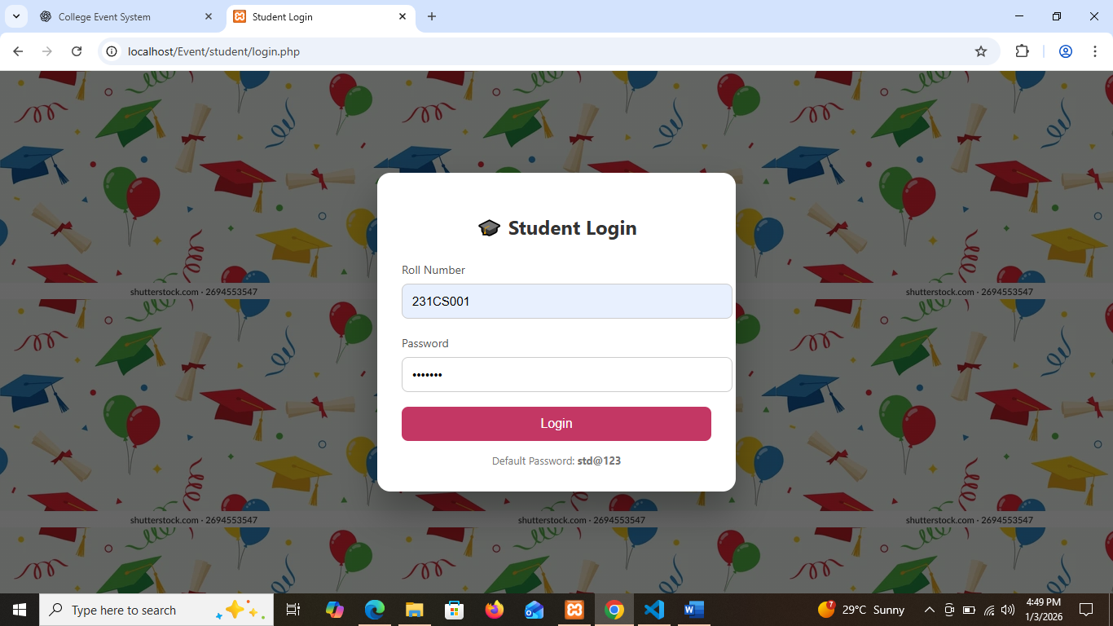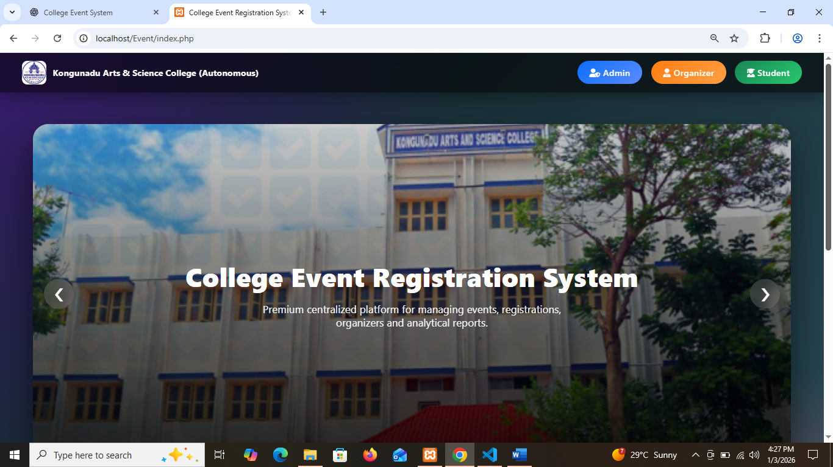**Index Page:**

**Student Login Page :**

**Student Dashboard :**

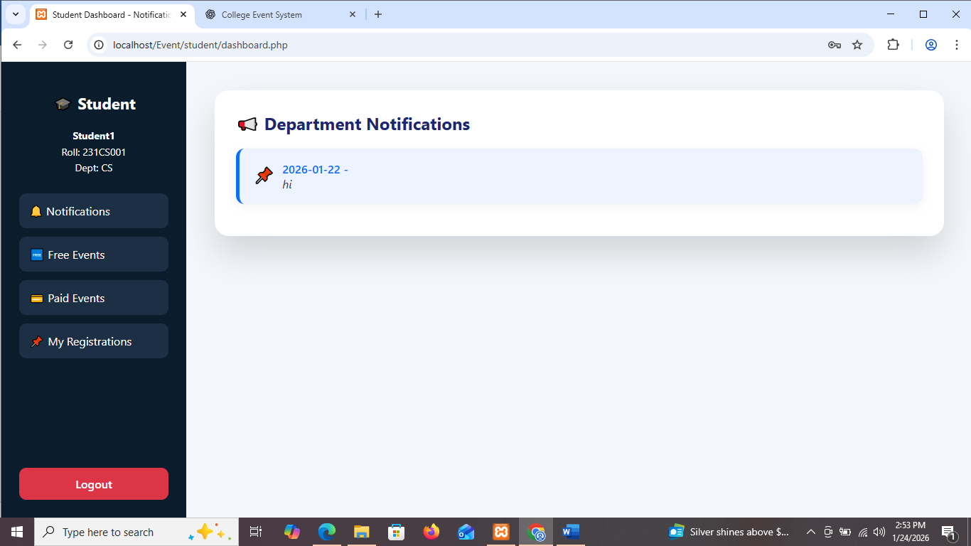

**Free Events :**

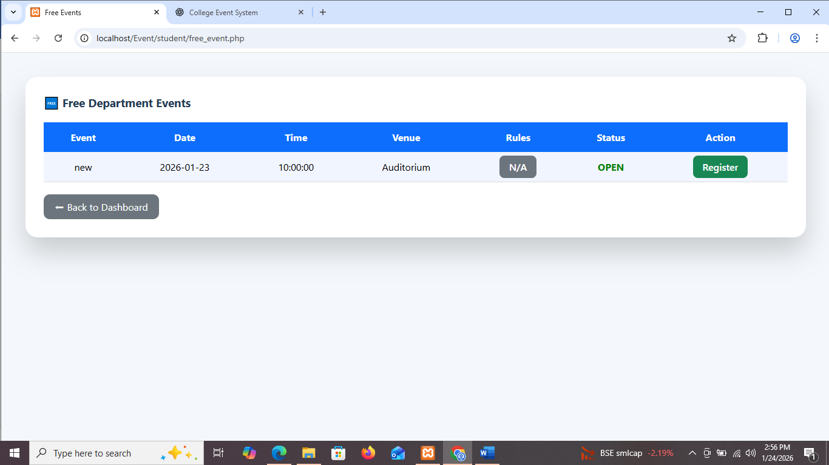

**Paid Events :**

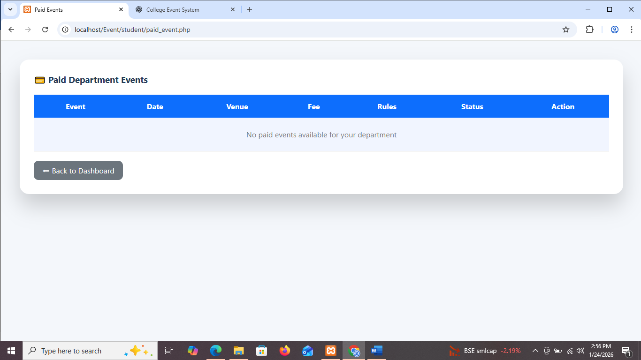

**Register Page :**

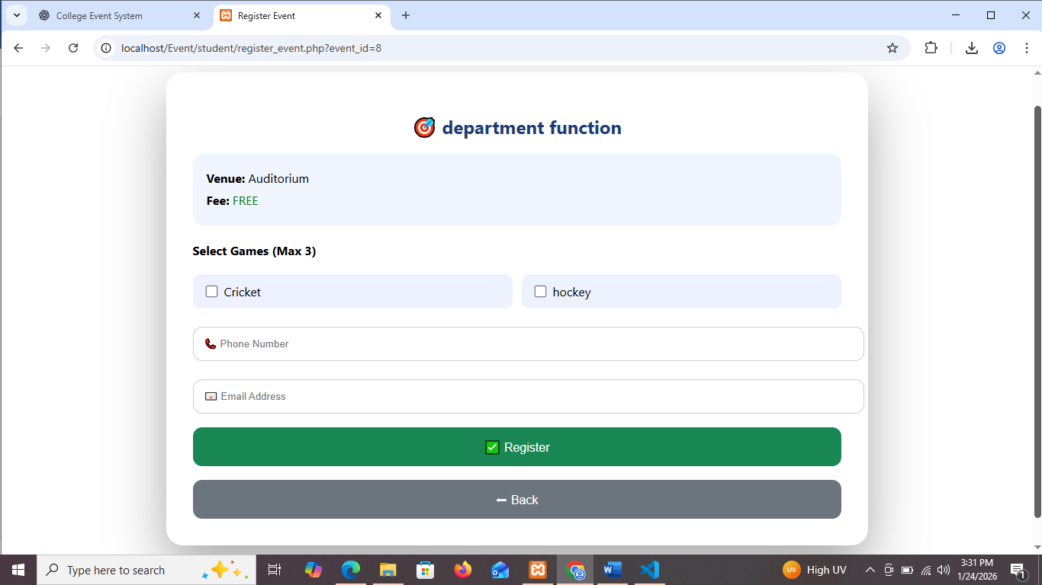

**My Registration Page :**

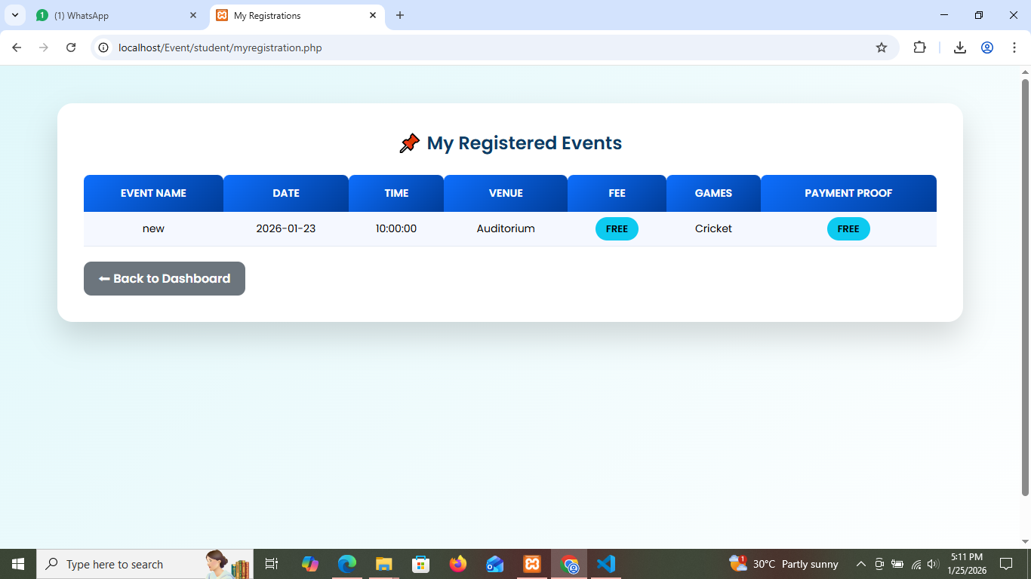

**Organizer Login :**

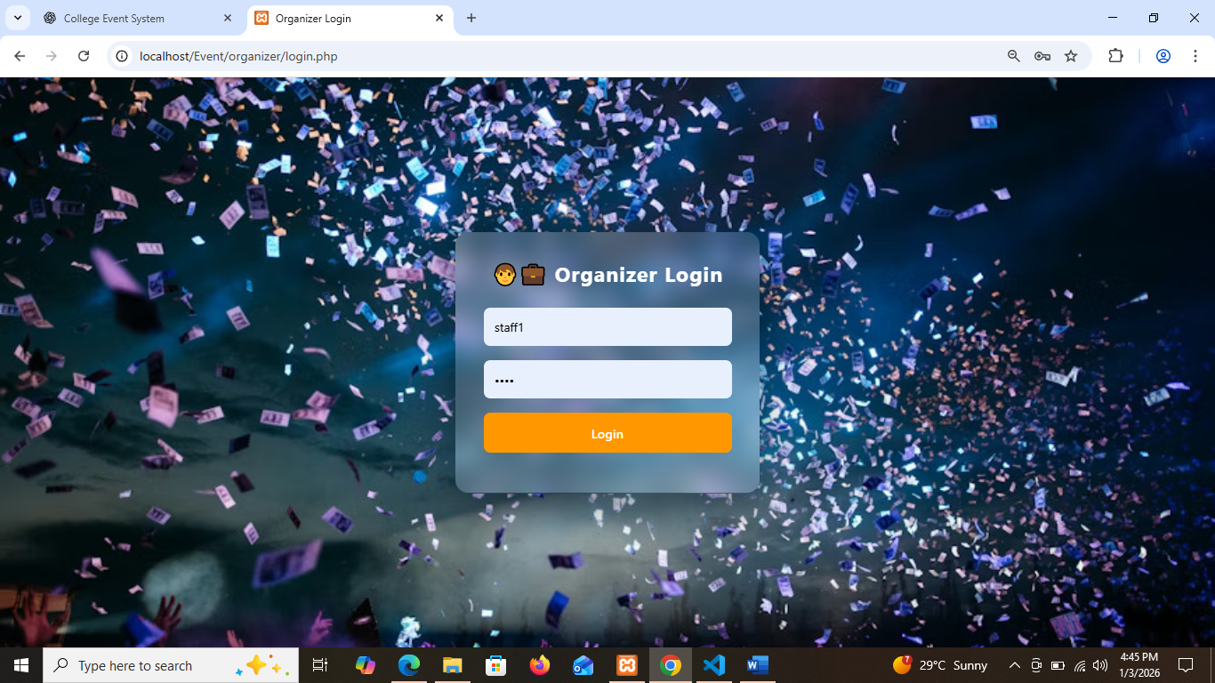

**Organizer Dashboard :**

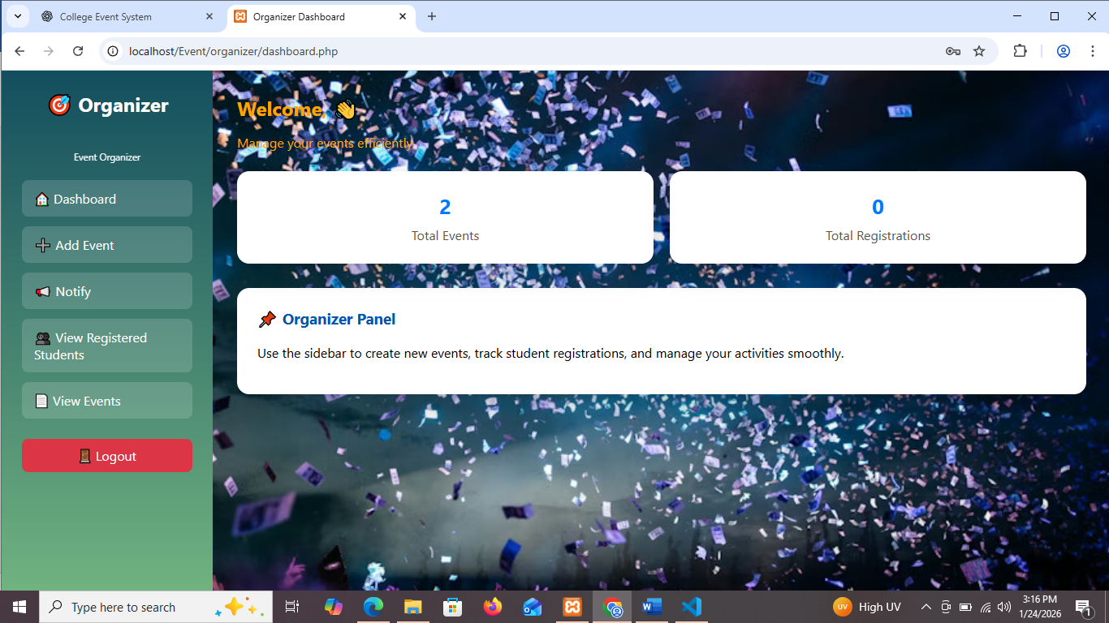

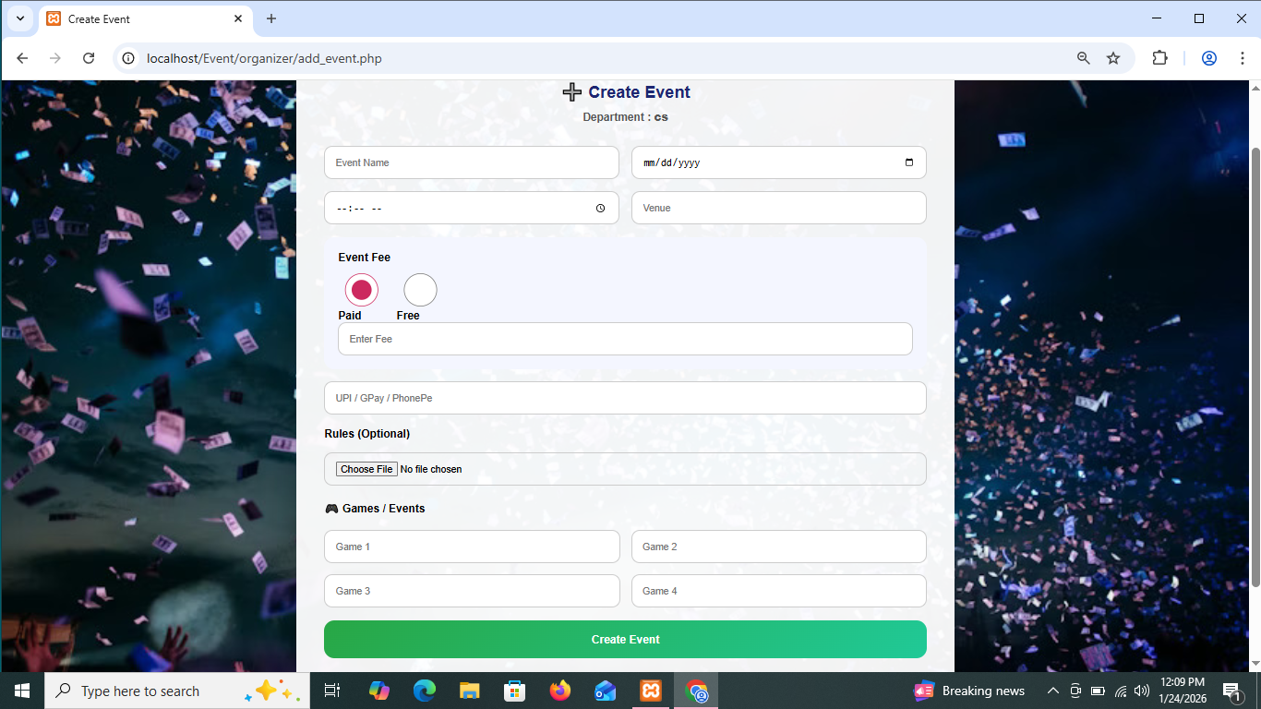**Create Event :**

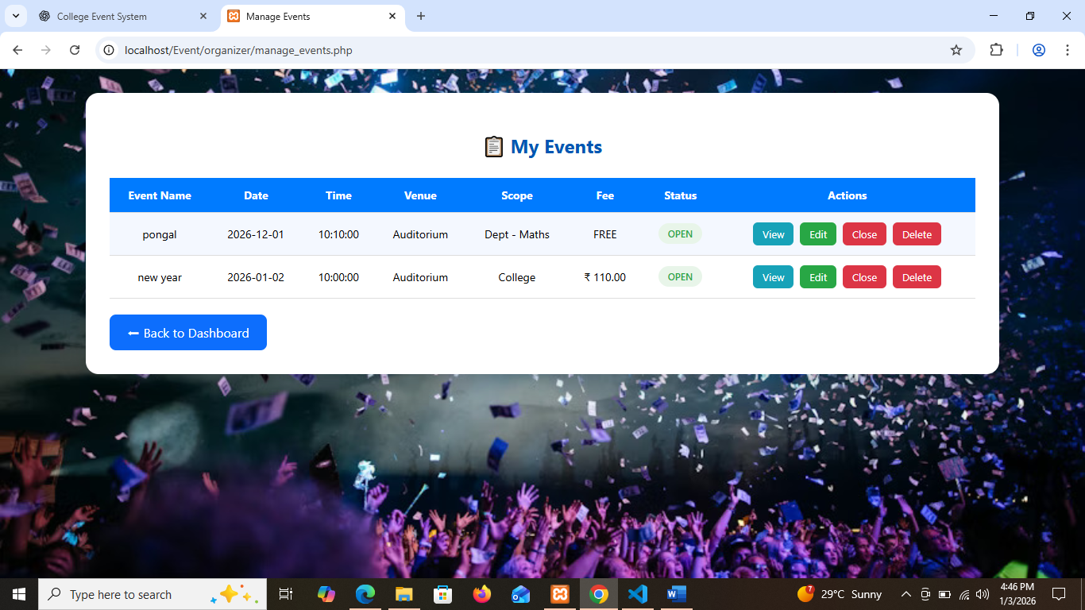**Event Details :**

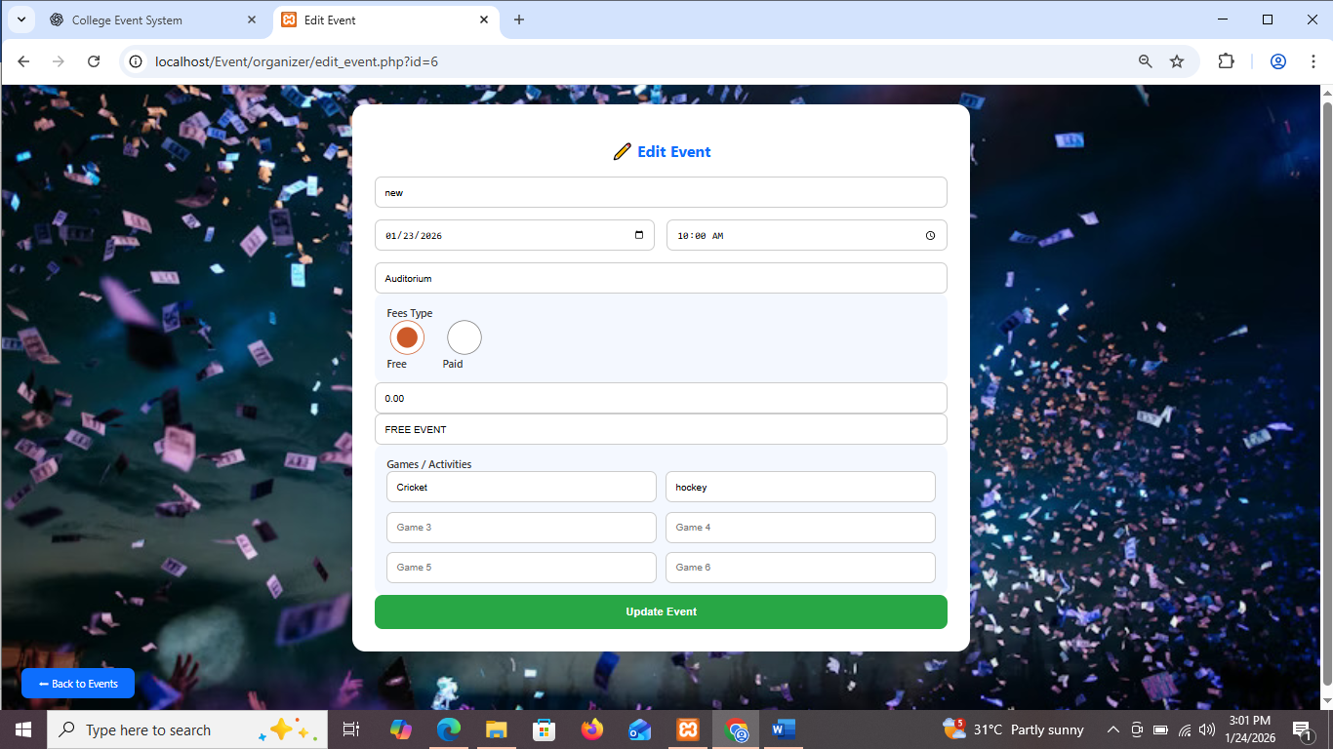**Edit Event :**

**Registered Student :**

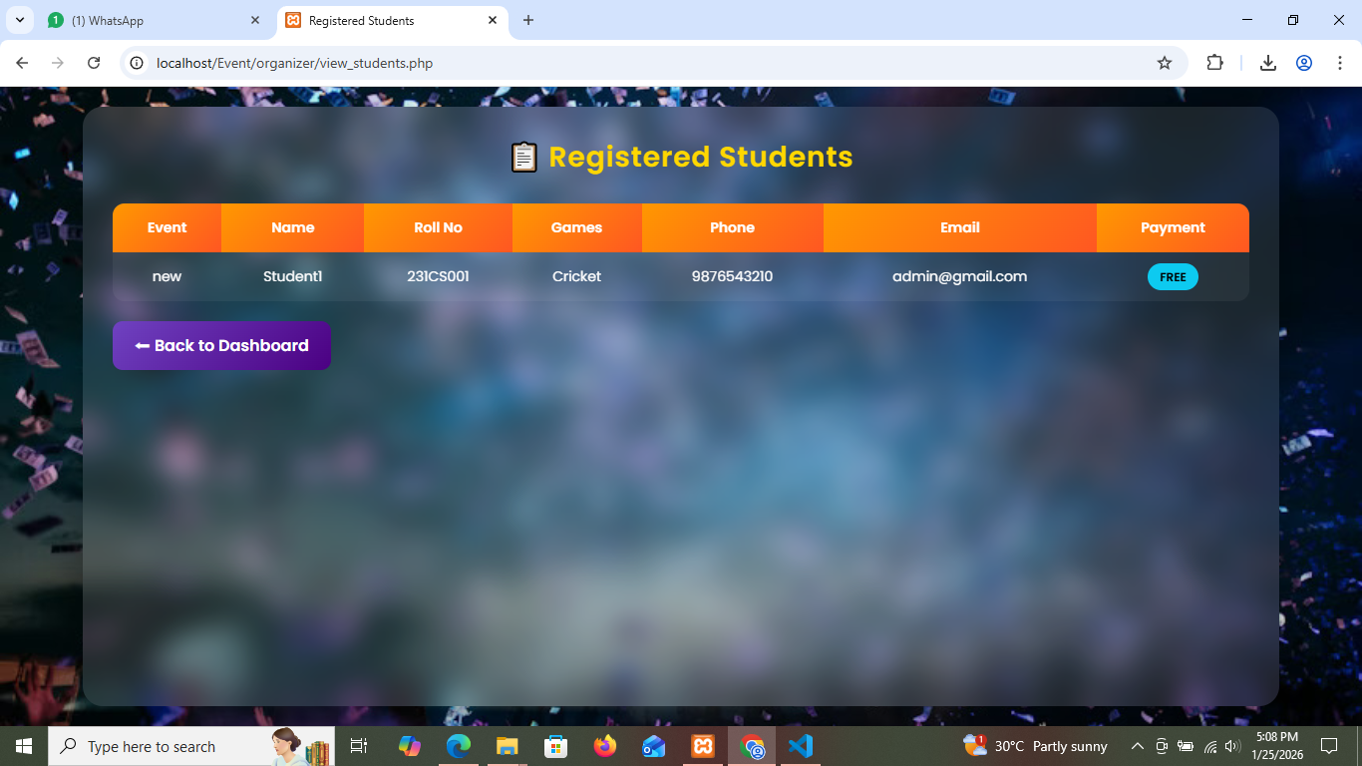

**Notification Send Page :**

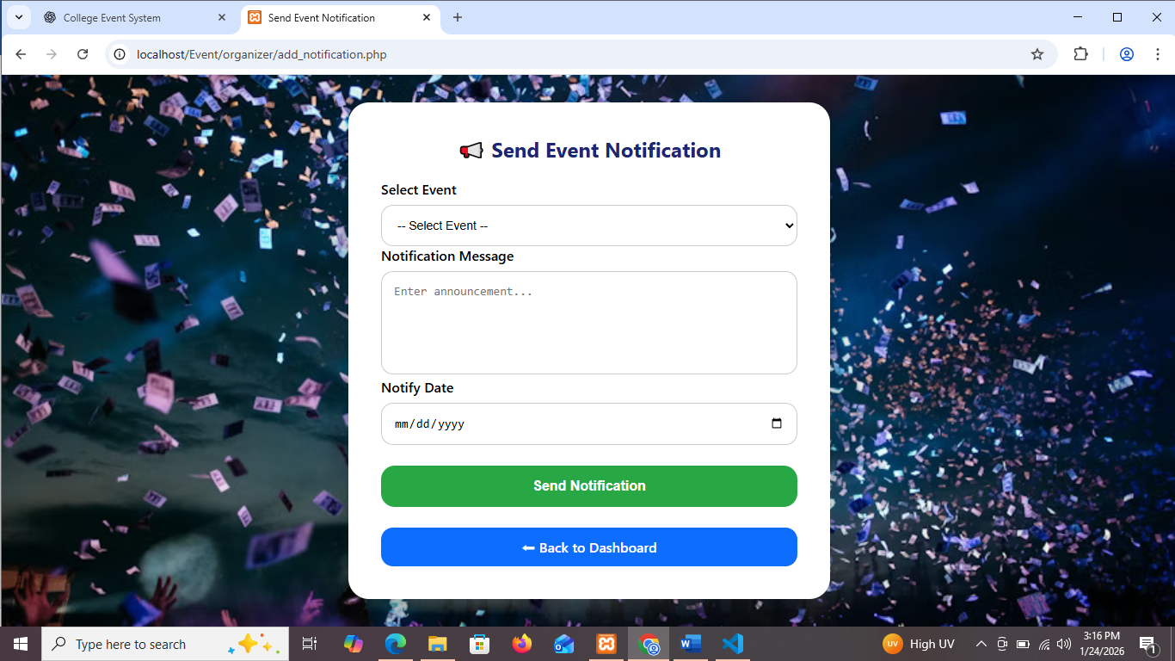

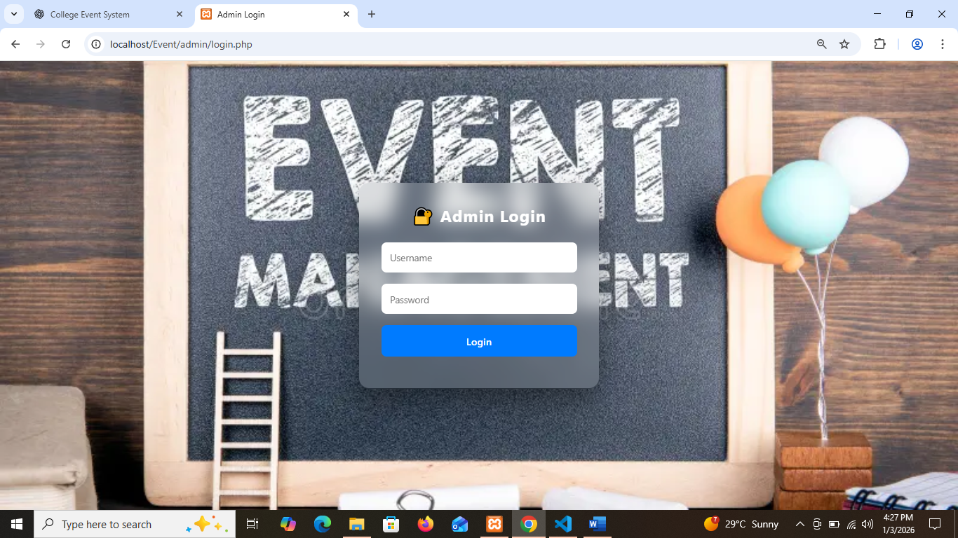**Admin Login Page :**

**Admin DashBoard :**

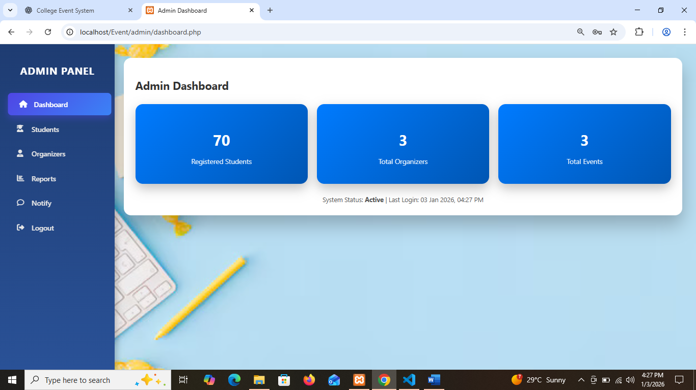

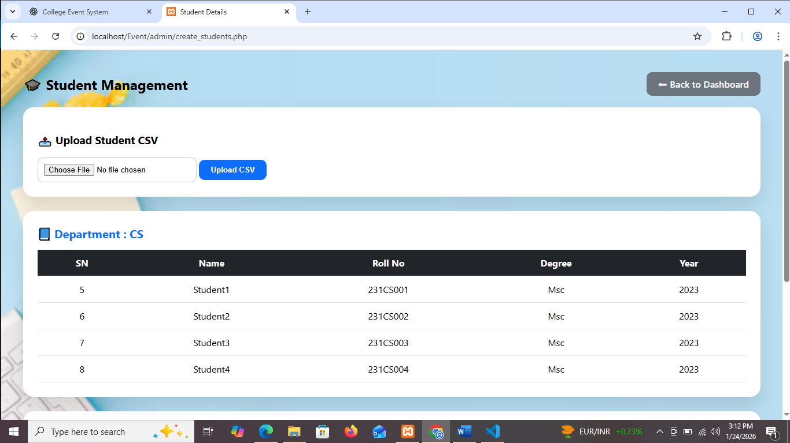**Create Student :**

**Create Organizer Page :**

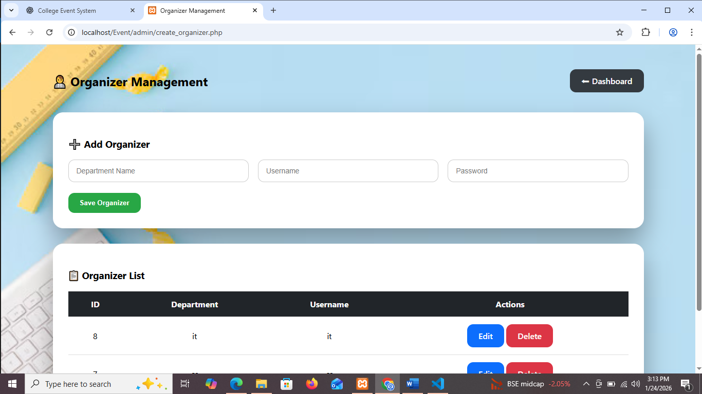

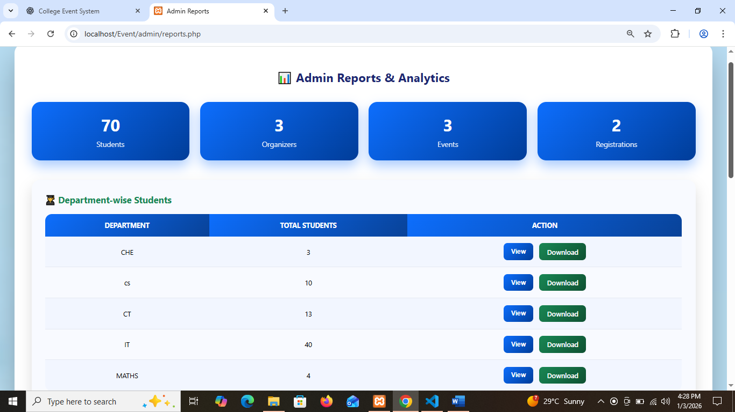**Report &analytics Page :**